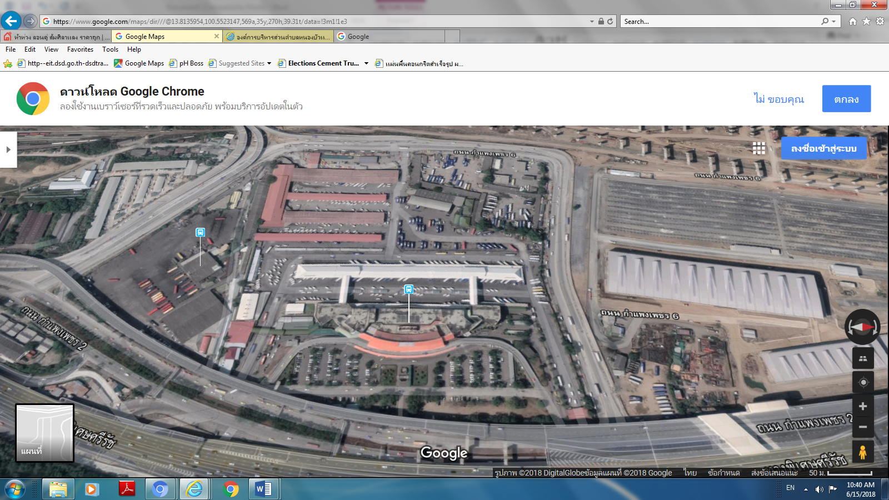

**Mo – Chit Bus Terminal Map**

**Platform 3 Van Terminal where you can find a crocodile booth ticket and which located at booth number 54.**

**At the front of Mo - chit station**